# PROJECT PLANNING PHASE Project Tracker, Velocity & Burndown Chart

|  |  |
| --- | --- |
| Date | 23 October 2022 |
| Team ID | PNT2022TMID08105 |
| Project Name | Analytics for Hospitals’ Healthcare Data |
| Maximum Marks | 8 Marks |

Project Tracker:

Total Story

Sprint

Points

Duration

Sprint End Date

Sprint Start Date

(

Planned)

Story Points

Completed (as on

Planned End Date)

Sprint Release Date

Actual)

(

Sprint-1

20

6

24

Days

Oct 2022

29

20

Oct 2022

29

Oct 2022

05

Nov 2022

20

05

Nov 2022

Oct 2022

31

Days

6

20

Sprint-2

07

Days

6

Nov 2022

20

Sprint-3

Nov 2022

12

20

12

Nov 2022

Days

19

6

Nov 2022

14

Nov 2022

19

Nov 2022

Sprint-4

20

20

Velocity:

Imagine we have a 10-day sprint duration, and the velocity of the team is 20 (points per sprint). Let’s calculate the team’s average velocity (AV) per iteration unit (story points per day)

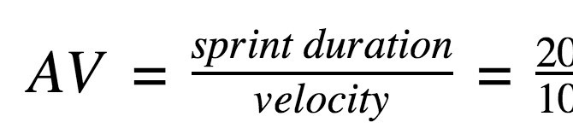

Burn Down Chart:

A burn down chart is a graphical representation of work left to do versus time. It is often used in agile software development methodologies such as Scrum. However, burn down charts can be applied to any project containing measurable progress over time.

|  |  |  |  |
| --- | --- | --- | --- |
| SPRINT | DATE | ESTIMATED EFFORT | ACTUAL EFFORT |
| SPRINT-1 | 24-OCT-22 | 20 | 20 |
| 25-0CT-22 | 19 | 20 |
| 26-OCT-22 | 18 | 19 |
| 27-OCT-22 | 17 | 19 |
| 28-OCT-22 | 17 | 18 |
| 29-OCT-22 | 16 | 17 |
| 30-OCT-22 | 15 | 15 |
| SPRINT-2 | 31-OCT-22 | 14 | 13 |
| 01-NOV-22 | 13 | 12 |
| 02-NOV-22 | 12 | 11 |
| 03-NOV-22 | 11 | 11 |
| 04-NOV-22 | 11 | 11 |
| 05-NOV-22 | 10 | 9 |
|  | 06-NOV-22 | 9 | 8 |
| SPRINT-3 | 07-NOV-22 | 8 | 7 |
| 08-NOV-22 | 7 | 6 |
| 09-NOV-22 | 6 | 6 |
| 10-NOV-22 | 5 | 5 |
| 11-NOV-22 | 5 | 5 |
| 12-NOV-22 | 5 | 5 |
| 13-NOV-22 | 4 | 4 |
| SPRINT-4 | 14-NOV-22 | 4 | 4 |
| 15-NOV-22 | 3 | 3 |
| 16-NOV-22 | 2 | 2 |
| 17-NOV-22 | 2 | 2 |
| 18-NOV-22 | 1 | 1 |
| 19-NOV-22 | 1 | 1 |

